Problem Set April 4, 2019
Tanner Jankins

1. New Synthesis of Nickel COD
Recently a new synthesis of Nickel COD was reported that uses a mild organic reductant instead of tradition methods that use DIBAL, Na or Et₃Al. In this two step process, first draw the mechanism for formation of 2 from 1. Then draw the mechanism of isolated 2 forming Nickel COD.

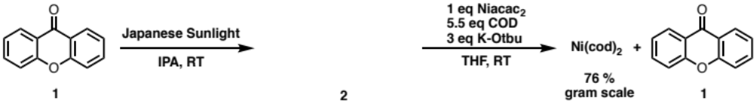
Organometallics, ASAP

2. Enzymes can do this reaction really well, and now so can rhodium. Draw a possible catalytic cycle for the reaction below. Remember every step is reversible.
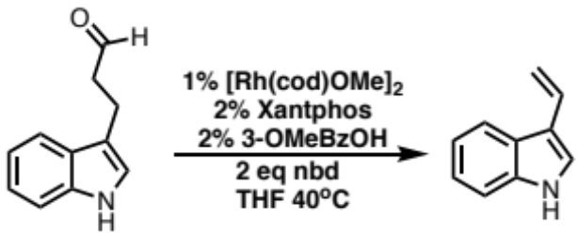
Science, 2015, 347, 57

3. Carbon Merry-Go-Round
In 2008 Takahashi reported a reversible carbon “Merry-go-round” with Ti-cp complexes. He tracked the movement of carbon by C¹³ (shown in red) labeling the cp rings. Let’s warm up by drawing a mechanism for the formation of 2 from 1. Next try to draw a mechanism from 2 to 3. Notice they used the placement of the methyl group from cp ring to rule out one particular mechanism. So if you draw something up and your methyl group isn’t in the right place, try breaking a different C-C bond. Remember, every step is reversible (until H+).

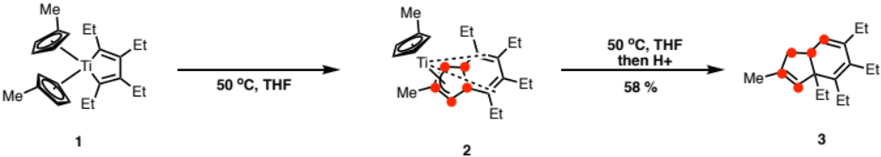
J. Am. Chem. Soc 2008, 130, 15236–15237

4. Build your own reversible reaction (Bonus/take home)
Using some of the things you learned above design a reversible reaction or functional group metathesis with an alkene and metal of choice. It doesn’t have to be “useful” or “practical”. See if you can use directed alkene functionalization as a driving force ie. An alkene is functionalized because it is attached to a directing group and the alkene formed is not, or some bonds are activated because they are attached to a directed group and the transfer alkene is not.

